江西财经大学
15－16学年第二学期期末考试试卷
试卷代码：12104A 授课课时：64(考试时间110分钟)
课程名称：概率论Probability and Statistics 适用对象：2014级国际学院

1. Fill in the blanks (3 points×5=15 points)
(1) Suppose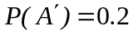,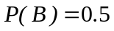,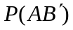=0.6, then 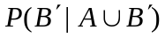= 5/7
(2)The area under the standard normal curve between -1.96 and 1.645 is 0.925
(3) A sample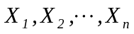is drawn from the population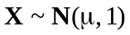. The observation value of sample mean is 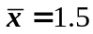,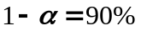. If n=16, then the confidence interval of 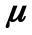 is ( 1.089,1.9113)
(4) If (X,Y) has a pdf 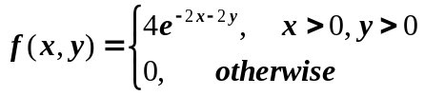 , then 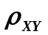(the correlation coefficient)=0
(5) The population has pmf
 | -1 | 0 | 1
 | /3 | 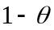 | 2/3

Set the mean value of a random sample is 1.5, then the moment estimate of parameter is 4.5
2. There are four choices in each question, but only one is correct. You should choose the correct one into the blank. (3 points×5=15 points)
(1) If X, Y are independent random variables, and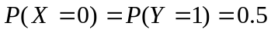,
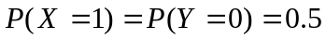, then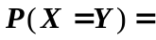( b )
a. 1 b. 0.5 c.0 .25 d. 0

(2) Suppose the pdf (probability density function) of X is 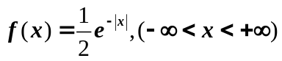, then the cdf (cumulative distribute function) is ( b )
a. 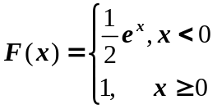. b. 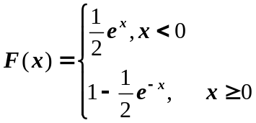
c. 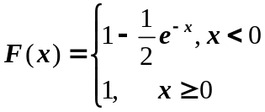. d. none of the above
(3) Iffollows a normal distribution，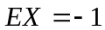，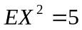，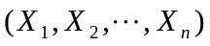 is a simple sample drawn from the population, then the distribution of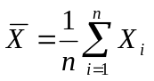is（ a ）
a.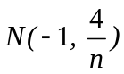 b.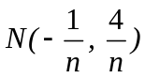 c.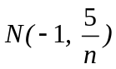 d.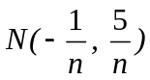
(4) A sample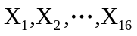is drawn from the population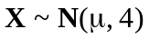, then which of the following interval is not the 95% confidence interval of ( c )
a. 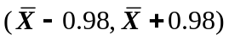 b. 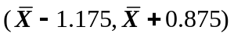
c. 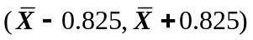 c. 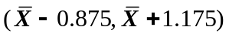

(5) In tests about a normal population mean()，the null hypothesis 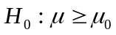, 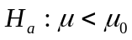. was rejected at significance level =0.05, if selected significance level =0.01，the decision is（ d ）
a. cannot be rejected b. 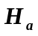 should be rejected
c. should be rejected d. could not conclude a result.

3. (12 points) Assuming in a batch of products, the proportion of first grade, second grade, and third grade is 60%, 30%, 10%, respectively. Someone took out a product randomly, and found it is not a third grade, then calculate the probability of it is a first grade.
Solution:
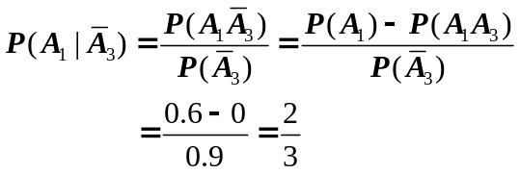

4. (14 points) Suppose random variable X and Y have joint pdf
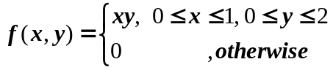
(a) Determine the marginal pdf of X and Y
(b) Calculate the expected value E(X+Y).
(c) Determine the conditional probability 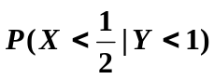
(d)Calculate the correlation coefficient 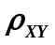
Solution：（a）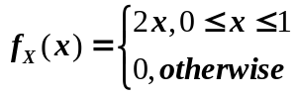 , 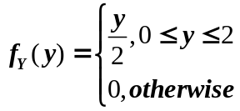
(b)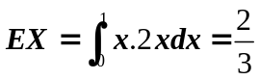 , 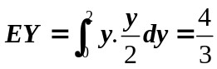,E(X+Y)=EX+EY=2
(c) 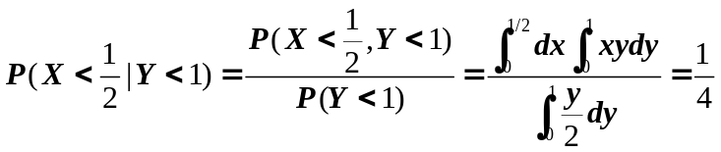
(d) 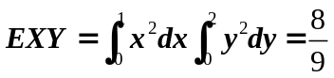,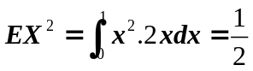,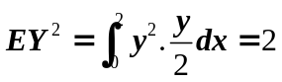
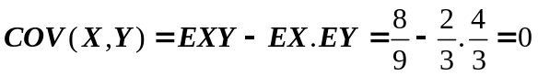
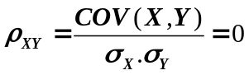

5. (12 points) Annie and Alvie have agreed to meet for lunch between noon (0:00 P.M) and 1:00 P.M. Denote Annie’s arrival time by X, Alvie’s by Y, and suppose X and Y are independent with pdf’s
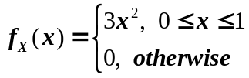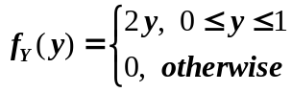
What is the expected amount of time that the one who arrives first must wait for the other person?
Solution:
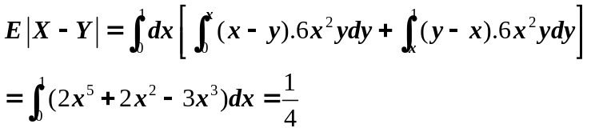

6. (12 points) Measuring the distance of a target, the measurement error is a random variable X(m), and X has normal distribution 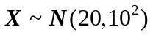. Please calculate the probability of at least one among three measurements which the absolute error less than 30m.
Solution: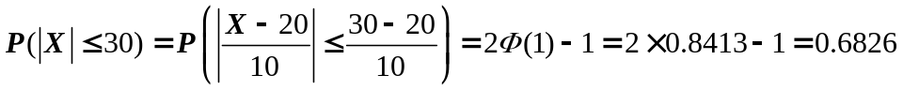
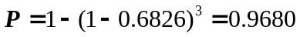

7. (10 points) The diameter of a kind of PVC pipe produced in a factory has normal distribution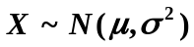. One day a sample of 9 pipes is selected, and the sample mean diameter is 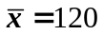mm, sample variance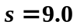.
(a) Determine the 95% confidence interval of true average diameter.
(b) Determine the 95% confidence interval of population variance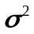 .
Solution: (a) CI is 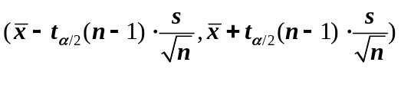 ,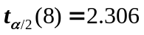
So, the confidence interval of is (113.082,126.918)
(b) CI is 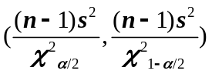,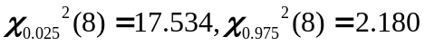
So, the confidence interval of is (36.957, 297.248)

8. (10 points) Let the test statistic Z have a standard normal distribution when 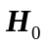 is true. Give the significance level for each of the following situations.
(a) 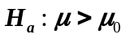 , rejection rejoin 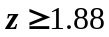
(b) 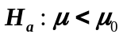, rejection rejoin 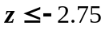
(c) 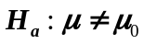, rejection rejoin 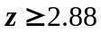 or 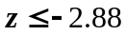
Solution: (a) rejection rejoin ,
the significance level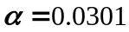
(b) rejection rejoin
the significance level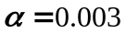
(c) rejection rejoin 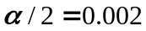
the significance level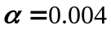

Table:
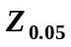 | 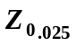 | 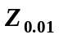 | 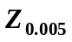
1.645 | 1.96 | 2.33 | 2.58

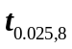 | 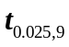 | 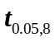 | 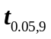
2.306 | 2.262 | 1.860 | 1.833

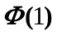 | 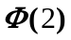 | 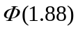 | 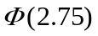 | 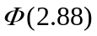
0.8413 | 0.9772 | 0.9699 | 0.9970 | 0.9980

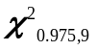 | 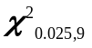 | 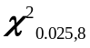 | 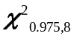 | 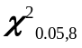 | 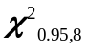 | 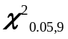 | 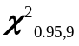
2.700 | 19.022 | 17.534 | 2.180 | 15.507 | 2.733 | 16.919 | 3.325

